atom@Atom-Pulse:~/MyExp/Java_rtk/projects/MyFirstProjectForGit$ sudo apt update
[sudo] password for atom:
Get:1 http://security.ubuntu.com/ubuntu noble-security InRelease [126 kB]
Get:2 https://packages.microsoft.com/repos/code stable InRelease [3,590 B]
Get:3 https://packages.microsoft.com/repos/code stable/main armhf Packages [20.6 kB]
Get:4 http://security.ubuntu.com/ubuntu noble-security/main amd64 Components [21.6 kB]
Get:5 https://packages.microsoft.com/repos/code stable/main arm64 Packages [20.6 kB]
Get:6 https://packages.microsoft.com/repos/code stable/main amd64 Packages [20.5 kB]
Get:7 http://security.ubuntu.com/ubuntu noble-security/restricted amd64 Components [212 B]
Get:8 http://security.ubuntu.com/ubuntu noble-security/universe amd64 Components [52.2 kB]
Get:9 http://security.ubuntu.com/ubuntu noble-security/multiverse amd64 Components [212 B]
Hit:10 http://archive.ubuntu.com/ubuntu noble InRelease
Get:11 http://archive.ubuntu.com/ubuntu noble-updates InRelease [126 kB]
Get:12 http://archive.ubuntu.com/ubuntu noble-backports InRelease [126 kB]
Get:13 http://archive.ubuntu.com/ubuntu noble-updates/main amd64 Packages [1,484 kB]
Get:14 http://packages.ros.org/ros2/ubuntu noble InRelease [4,676 B]
Err:14 http://packages.ros.org/ros2/ubuntu noble InRelease
The following signatures were invalid: EXPKEYSIG F42ED6FBAB17C654 Open Robotics <info@osrfoundation.org>
Get:15 http://archive.ubuntu.com/ubuntu noble-updates/main amd64 Components [175 kB]
Get:16 http://archive.ubuntu.com/ubuntu noble-updates/restricted amd64 Components [212 B]
Get:17 http://archive.ubuntu.com/ubuntu noble-updates/universe amd64 Packages [1,486 kB]
Get:18 http://archive.ubuntu.com/ubuntu noble-updates/universe amd64 Components [377 kB]
Get:19 http://archive.ubuntu.com/ubuntu noble-updates/multiverse amd64 Components [940 B]
Get:20 http://archive.ubuntu.com/ubuntu noble-backports/main amd64 Components [7,140 B]
Get:21 http://archive.ubuntu.com/ubuntu noble-backports/restricted amd64 Components [216 B]
Get:22 http://archive.ubuntu.com/ubuntu noble-backports/universe amd64 Components [11.0 kB]
Get:23 http://archive.ubuntu.com/ubuntu noble-backports/multiverse amd64 Components [212 B]
Fetched 4,064 kB in 6s (666 kB/s)
Reading package lists... Done
Building dependency tree... Done
Reading state information... Done
68 packages can be upgraded. Run 'apt list --upgradable' to see them.
W: An error occurred during the signature verification. The repository is not updated and the previous index files will be used. GPG error: http://packages.ros.org/ros2/ubuntu noble InRelease: The following signatures were invalid: EXPKEYSIG F42ED6FBAB17C654 Open Robotics <info@osrfoundation.org>
W: Failed to fetch http://packages.ros.org/ros2/ubuntu/dists/noble/InRelease The following signatures were invalid: EXPKEYSIG F42ED6FBAB17C654 Open Robotics <info@osrfoundation.org>
W: Some index files failed to download. They have been ignored, or old ones used instead.
atom@Atom-Pulse:~/MyExp/Java_rtk/projects/MyFirstProjectForGit$ sudo apt install apt-transport-https ca-certificates curl
Reading package lists... Done
Building dependency tree... Done
Reading state information... Done
ca-certificates is already the newest version (20240203).
ca-certificates set to manually installed.
curl is already the newest version (8.5.0-2ubuntu10.6).
The following packages were automatically installed and are no longer required:
libgl1-amber-dri libglapi-mesa nvidia-firmware-535-535.230.02
Use 'sudo apt autoremove' to remove them.
The following NEW packages will be installed:
apt-transport-https
0 upgraded, 1 newly installed, 0 to remove and 68 not upgraded.
Need to get 3,970 B of archives.
After this operation, 36.9 kB of additional disk space will be used.
Do you want to continue? [Y/n] y
Get:1 http://archive.ubuntu.com/ubuntu noble-updates/universe amd64 apt-transport-https all 2.8.3 [3,970 B]
Fetched 3,970 B in 0s (24.3 kB/s)
Selecting previously unselected package apt-transport-https.
(Reading database ... 352329 files and directories currently installed.)
Preparing to unpack .../apt-transport-https_2.8.3_all.deb ...

Progress: [ 0%] [.......................................................................................................................................................]
Unpacking apt-transport-https (2.8.3) ...#######.........................................................................................................................]

Setting up apt-transport-https (2.8.3) ...####################################...........................................................................................]

Progress: [ 60%] [##########################################################################################.............................................................]
atom@Atom-Pulse:~/MyExp/Java_rtk/projects/MyFirstProjectForGit$ sudo install -m 0755 -d /etc/apt/keyrings
atom@Atom-Pulse:~/MyExp/Java_rtk/projects/MyFirstProjectForGit$ curl -fsSL https://download.docker.com/linux/ubuntu/gpg | sudo gpg --dearmor -o /etc/apt/keyrings/docker.gpg
atom@Atom-Pulse:~/MyExp/Java_rtk/projects/MyFirstProjectForGit$ sudo chmod a+r /etc/apt/keyrings/docker.gpg
atom@Atom-Pulse:~/MyExp/Java_rtk/projects/MyFirstProjectForGit$ echo \
"deb [arch="$(dpkg --print-architecture)" signed-by=/etc/apt/keyrings/docker.gpg] https://download.docker.com/linux/ubuntu \
"$(. /etc/os-release && echo "$VERSION_CODENAME")" stable" | \
sudo tee /etc/apt/sources.list.d/docker.list > /dev/null
atom@Atom-Pulse:~/MyExp/Java_rtk/projects/MyFirstProjectForGit$ sudo apt update
Hit:1 http://security.ubuntu.com/ubuntu noble-security InRelease
Get:2 https://download.docker.com/linux/ubuntu noble InRelease [48.8 kB]
Get:3 https://download.docker.com/linux/ubuntu noble/stable amd64 Packages [31.9 kB]
Get:4 http://packages.ros.org/ros2/ubuntu noble InRelease [4,676 B]
Hit:5 http://archive.ubuntu.com/ubuntu noble InRelease
Hit:6 https://packages.microsoft.com/repos/code stable InRelease
Err:4 http://packages.ros.org/ros2/ubuntu noble InRelease
The following signatures were invalid: EXPKEYSIG F42ED6FBAB17C654 Open Robotics <info@osrfoundation.org>
Hit:7 http://archive.ubuntu.com/ubuntu noble-updates InRelease
Hit:8 http://archive.ubuntu.com/ubuntu noble-backports InRelease
Fetched 85.4 kB in 1s (84.7 kB/s)
Reading package lists... Done
Building dependency tree... Done
Reading state information... Done
68 packages can be upgraded. Run 'apt list --upgradable' to see them.
W: An error occurred during the signature verification. The repository is not updated and the previous index files will be used. GPG error: http://packages.ros.org/ros2/ubuntu noble InRelease: The following signatures were invalid: EXPKEYSIG F42ED6FBAB17C654 Open Robotics <info@osrfoundation.org>
W: Failed to fetch http://packages.ros.org/ros2/ubuntu/dists/noble/InRelease The following signatures were invalid: EXPKEYSIG F42ED6FBAB17C654 Open Robotics <info@osrfoundation.org>
W: Some index files failed to download. They have been ignored, or old ones used instead.
atom@Atom-Pulse:~/MyExp/Java_rtk/projects/MyFirstProjectForGit$ sudo apt install docker-ce docker-ce-cli containerd.io docker-buildx-plugin docker-compose-plugin
Reading package lists... Done
Building dependency tree... Done
Reading state information... Done
The following packages were automatically installed and are no longer required:
libgl1-amber-dri libglapi-mesa nvidia-firmware-535-535.230.02
Use 'sudo apt autoremove' to remove them.
The following additional packages will be installed:
docker-ce-rootless-extras libslirp0 pigz slirp4netns
Suggested packages:
cgroupfs-mount | cgroup-lite docker-model-plugin
The following NEW packages will be installed:
containerd.io docker-buildx-plugin docker-ce docker-ce-cli docker-ce-rootless-extras docker-compose-plugin libslirp0 pigz slirp4netns
0 upgraded, 9 newly installed, 0 to remove and 68 not upgraded.
Need to get 105 MB of archives.
After this operation, 437 MB of additional disk space will be used.
Do you want to continue? [Y/n] y
Get:1 http://archive.ubuntu.com/ubuntu noble/universe amd64 pigz amd64 2.8-1 [65.6 kB]
Get:2 http://archive.ubuntu.com/ubuntu noble/main amd64 libslirp0 amd64 4.7.0-1ubuntu3 [63.8 kB]
Get:3 http://archive.ubuntu.com/ubuntu noble/universe amd64 slirp4netns amd64 1.2.1-1build2 [34.9 kB]
Get:4 https://download.docker.com/linux/ubuntu noble/stable amd64 containerd.io amd64 1.7.28-0~ubuntu.24.04~noble [31.9 MB]
Get:5 https://download.docker.com/linux/ubuntu noble/stable amd64 docker-ce-cli amd64 5:28.5.0-1~ubuntu.24.04~noble [16.4 MB]
Get:6 https://download.docker.com/linux/ubuntu noble/stable amd64 docker-ce amd64 5:28.5.0-1~ubuntu.24.04~noble [19.7 MB]
Get:7 https://download.docker.com/linux/ubuntu noble/stable amd64 docker-buildx-plugin amd64 0.29.1-1~ubuntu.24.04~noble [15.9 MB]
Get:8 https://download.docker.com/linux/ubuntu noble/stable amd64 docker-ce-rootless-extras amd64 5:28.5.0-1~ubuntu.24.04~noble [6,479 kB]
Get:9 https://download.docker.com/linux/ubuntu noble/stable amd64 docker-compose-plugin amd64 2.39.4-0~ubuntu.24.04~noble [14.2 MB]
Fetched 105 MB in 17s (6,351 kB/s)
Selecting previously unselected package containerd.io.
(Reading database ... 352333 files and directories currently installed.)
Preparing to unpack .../0-containerd.io_1.7.28-0~ubuntu.24.04~noble_amd64.deb ...

Progress: [ 0%] [.......................................................................................................................................................]
Unpacking containerd.io (1.7.28-0~ubuntu.24.04~noble) ...................................................................................................................]

Selecting previously unselected package docker-ce-cli....................................................................................................................]
Preparing to unpack .../1-docker-ce-cli_5%3a28.5.0-1~ubuntu.24.04~noble_amd64.deb ...

Unpacking docker-ce-cli (5:28.5.0-1~ubuntu.24.04~noble) .................................................................................................................]

Selecting previously unselected package docker-ce........................................................................................................................]
Preparing to unpack .../2-docker-ce_5%3a28.5.0-1~ubuntu.24.04~noble_amd64.deb ...

Unpacking docker-ce (5:28.5.0-1~ubuntu.24.04~noble) .....................................................................................................................]

Selecting previously unselected package pigz.............................................................................................................................]
Preparing to unpack .../3-pigz_2.8-1_amd64.deb ...

Unpacking pigz (2.8-1) ...####################...........................................................................................................................]

Selecting previously unselected package docker-buildx-plugin.............................................................................................................]
Preparing to unpack .../4-docker-buildx-plugin_0.29.1-1~ubuntu.24.04~noble_amd64.deb ...

Unpacking docker-buildx-plugin (0.29.1-1~ubuntu.24.04~noble) ............................................................................................................]

Selecting previously unselected package docker-ce-rootless-extras........................................................................................................]
Preparing to unpack .../5-docker-ce-rootless-extras_5%3a28.5.0-1~ubuntu.24.04~noble_amd64.deb ...

Unpacking docker-ce-rootless-extras (5:28.5.0-1~ubuntu.24.04~noble) .....................................................................................................]

Selecting previously unselected package docker-compose-plugin.####.......................................................................................................]
Preparing to unpack .../6-docker-compose-plugin_2.39.4-0~ubuntu.24.04~noble_amd64.deb ...

Unpacking docker-compose-plugin (2.39.4-0~ubuntu.24.04~noble) ...######..................................................................................................]

Selecting previously unselected package libslirp0:amd64.###################..............................................................................................]
Preparing to unpack .../7-libslirp0_4.7.0-1ubuntu3_amd64.deb ...

Unpacking libslirp0:amd64 (4.7.0-1ubuntu3) ...#################################..........................................................................................]

Selecting previously unselected package slirp4netns.###############################......................................................................................]
Preparing to unpack .../8-slirp4netns_1.2.1-1build2_amd64.deb ...

Unpacking slirp4netns (1.2.1-1build2) ...##############################################..................................................................................]

Setting up docker-buildx-plugin (0.29.1-1~ubuntu.24.04~noble) ...##########################..............................................................................]

Progress: [ 51%] [#############################################################################..........................................................................]
Setting up containerd.io (1.7.28-0~ubuntu.24.04~noble) ...#########################################......................................................................]

Created symlink /etc/systemd/system/multi-user.target.wants/containerd.service → /usr/lib/systemd/system/containerd.service..............................................]

Setting up docker-compose-plugin (2.39.4-0~ubuntu.24.04~noble) ...#########################################..............................................................]

Progress: [ 62%] [#############################################################################################..........................................................]
Setting up docker-ce-cli (5:28.5.0-1~ubuntu.24.04~noble) ...#######################################################......................................................]

Progress: [ 68%] [######################################################################################################.................................................]
Setting up libslirp0:amd64 (4.7.0-1ubuntu3) ...#############################################################################.............................................]

Progress: [ 73%] [##############################################################################################################.........................................]
Setting up pigz (2.8-1) ...#########################################################################################################.....................................]

Progress: [ 78%] [######################################################################################################################.................................]
Setting up docker-ce-rootless-extras (5:28.5.0-1~ubuntu.24.04~noble) ...####################################################################.............................]

Progress: [ 84%] [##############################################################################################################################.........................]
Setting up slirp4netns (1.2.1-1build2) ...##########################################################################################################.....................]

Progress: [ 89%] [######################################################################################################################################.................]
Setting up docker-ce (5:28.5.0-1~ubuntu.24.04~noble) ...####################################################################################################.............]

Created symlink /etc/systemd/system/multi-user.target.wants/docker.service → /usr/lib/systemd/system/docker.service.############################################.........]
Created symlink /etc/systemd/system/sockets.target.wants/docker.socket → /usr/lib/systemd/system/docker.socket.

Processing triggers for man-db (2.12.0-4build2) ...#################################################################################################################.....]
Processing triggers for libc-bin (2.39-0ubuntu8.6) ...
atom@Atom-Pulse:~/MyExp/Java_rtk/projects/MyFirstProjectForGit$ docker --version
Docker version 28.5.0, build 887030f
atom@Atom-Pulse:~/MyExp/Java_rtk/projects/MyFirstProjectForGit$

Устан

atom@Atom-Pulse:~/MyExp/Java_rtk/projects/MyFirstProjectForGit$ docker run --name my-postgres \
-e POSTGRES_PASSWORD=mypassword \
-p 5432:5432 \
-d postgres:12
docker: permission denied while trying to connect to the Docker daemon socket at unix:///var/run/docker.sock: Head "http://%2Fvar%2Frun%2Fdocker.sock/_ping": dial unix /var/run/docker.sock: connect: permission denied

Run 'docker run --help' for more information
atom@Atom-Pulse:~/MyExp/Java_rtk/projects/MyFirstProjectForGit$ sudo docker run --name my-postgres \
-e POSTGRES_PASSWORD=mypassword \
-p 5432:5432 \
-d postgres:12
Unable to find image 'postgres:12' locally
12: Pulling from library/postgres
af302e5c37e9: Pull complete
2658fb88e359: Pull complete
babbdc5b0246: Pull complete
c7e87d67b959: Pull complete
88f756509b50: Pull complete
609e5172992b: Pull complete
d2bfee31de74: Pull complete
230439b44bcf: Pull complete
15e8e49e6e16: Pull complete
44a010192fbf: Pull complete
3acaa28c473b: Pull complete
641e9ef876e8: Pull complete
7fcd35e7a6ca: Pull complete
aa4e9c1cec74: Pull complete
Digest: sha256:2f2a8c2a7d10862e7fba2602e304523554f9df8244c632dafe2628ccb398fb5c
Status: Downloaded newer image for postgres:12
7c1b46bfaaa38710528adaae618da53d1bc8419ed143e4dcfb0acaf479b50cd9
atom@Atom-Pulse:~/MyExp/Java_rtk/projects/MyFirstProjectForGit$ docker ps
permission denied while trying to connect to the Docker daemon socket at unix:///var/run/docker.sock: Get "http://%2Fvar%2Frun%2Fdocker.sock/v1.51/containers/json": dial unix /var/run/docker.sock: connect: permission denied
atom@Atom-Pulse:~/MyExp/Java_rtk/projects/MyFirstProjectForGit$ sudo docker ps
CONTAINER ID IMAGE COMMAND CREATED STATUS PORTS NAMES
7c1b46bfaaa3 postgres:12 "docker-entrypoint.s…" About a minute ago Up About a minute 0.0.0.0:5432->5432/tcp, [::]:5432->5432/tcp my-postgres
atom@Atom-Pulse:~/MyExp/Java_rtk/projects/MyFirstProjectForGit$ sudo apt install postgresql-client
Reading package lists... Done
Building dependency tree... Done
Reading state information... Done
The following packages were automatically installed and are no longer required:
libgl1-amber-dri libglapi-mesa nvidia-firmware-535-535.230.02
Use 'sudo apt autoremove' to remove them.
The following additional packages will be installed:
postgresql-client-16 postgresql-client-common
Suggested packages:
postgresql-16 postgresql-doc-16
The following NEW packages will be installed:
postgresql-client postgresql-client-16 postgresql-client-common
0 upgraded, 3 newly installed, 0 to remove and 68 not upgraded.
Need to get 1,345 kB of archives.
After this operation, 4,518 kB of additional disk space will be used.
Do you want to continue? [Y/n] y
Abort.
atom@Atom-Pulse:~/MyExp/Java_rtk/projects/MyFirstProjectForGit$ sudo apt install postgresql-client
Reading package lists... Done
Building dependency tree... Done
Reading state information... Done
The following packages were automatically installed and are no longer required:
libgl1-amber-dri libglapi-mesa nvidia-firmware-535-535.230.02
Use 'sudo apt autoremove' to remove them.
The following additional packages will be installed:
postgresql-client-16 postgresql-client-common
Suggested packages:
postgresql-16 postgresql-doc-16
The following NEW packages will be installed:
postgresql-client postgresql-client-16 postgresql-client-common
0 upgraded, 3 newly installed, 0 to remove and 68 not upgraded.
Need to get 1,345 kB of archives.
After this operation, 4,518 kB of additional disk space will be used.
Do you want to continue? [Y/n] y
Get:1 http://archive.ubuntu.com/ubuntu noble-updates/main amd64 postgresql-client-common all 257build1.1 [36.4 kB]
Get:2 http://archive.ubuntu.com/ubuntu noble-updates/main amd64 postgresql-client-16 amd64 16.10-0ubuntu0.24.04.1 [1,297 kB]
Get:3 http://archive.ubuntu.com/ubuntu noble-updates/main amd64 postgresql-client all 16+257build1.1 [11.6 kB]
Fetched 1,345 kB in 8s (172 kB/s)
Selecting previously unselected package postgresql-client-common.
(Reading database ... 352594 files and directories currently installed.)
Preparing to unpack .../postgresql-client-common_257build1.1_all.deb ...

Progress: [ 0%] [.......................................................................................................................................................]
Unpacking postgresql-client-common (257build1.1) ........................................................................................................................]

Selecting previously unselected package postgresql-client-16.............................................................................................................]
Preparing to unpack .../postgresql-client-16_16.10-0ubuntu0.24.04.1_amd64.deb ...

Unpacking postgresql-client-16 (16.10-0ubuntu0.24.04.1) .................................................................................................................]

Selecting previously unselected package postgresql-client.######.........................................................................................................]
Preparing to unpack .../postgresql-client_16+257build1.1_all.deb ...

Unpacking postgresql-client (16+257build1.1) ...############################.............................................................................................]

Setting up postgresql-client-common (257build1.1) ...##################################..................................................................................]

Progress: [ 54%] [#################################################################################......................................................................]
Setting up postgresql-client-16 (16.10-0ubuntu0.24.04.1) ...##################################################...........................................................]

update-alternatives: using /usr/share/postgresql/16/man/man1/psql.1.gz to provide /usr/share/man/man1/psql.1.gz (psql.1.gz) in auto mode.................................]

Setting up postgresql-client (16+257build1.1) ...#####################################################################################...................................]

Progress: [ 85%] [###############################################################################################################################........................]
Processing triggers for man-db (2.12.0-4build2) ...##########################################################################################################............]
atom@Atom-Pulse:~/MyExp/Java_rtk/projects/MyFirstProjectForGit$ psql -h localhost -U postgres -d postgres
Password for user postgres:
psql (16.10 (Ubuntu 16.10-0ubuntu0.24.04.1), server 12.22 (Debian 12.22-1.pgdg120+1))
Type "help" for help.

postgres=# psql: \q
atom@Atom-Pulse:~/MyExp/Java_rtk/projects/MyFirstProjectForGit$

=======================================================================

Подключите PostgreSQL к IntelliJ IDEA
Теперь перейдём в IDEA и создадим Data Source для подключения к вашему контейнеру.

1. Откройте панель Database
- В правой части IDEA нажмите на иконку Database (или: View → Tool Windows → Database).
Если панели нет — убедитесь, что плагин Database Tools and SQL включён:
Settings (Ctrl+Alt+S) → Plugins → Installed → Database Tools and SQL → должен быть активен.

2. Создайте новый Data Source
- Нажмите на + (New) → Data Source → PostgreSQL

3. Заполните параметры подключения
Вкладка General:
- Host: localhost
- Port: 5432 (стандартный)
- Database: postgres (база по умолчанию)
- User: postgres
- Password: mypassword
- Authentication: User & Password
⚠️ Не меняйте драйвер — оставьте дефолтный. IDEA сама скачает нужный JDBC-драйвер, если его нет.

4. Протестируйте подключение
Нажмите Test Connection внизу окна.
✅ Если увидите: “Connection successful” — всё готово!

5. Сохраните и закройте
Нажмите OK.
В панели Database появится ваша база с иконкой 🐘.

Скрины:
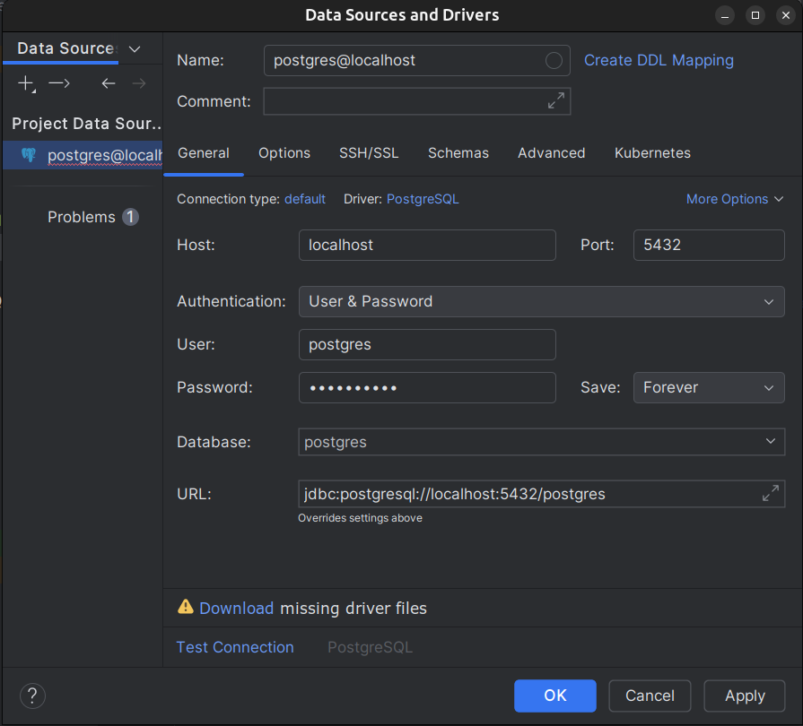

Проверьте работу (по желанию)
- Кликните по вашему соединению → нажмите F4 — откроется SQL Console.
- Введите запрос:
sql
1
SELECT version();

Нажмите Ctrl+Enter или кнопку ▶️ — вы должны увидеть версию PostgreSQL (должна быть 12.x).
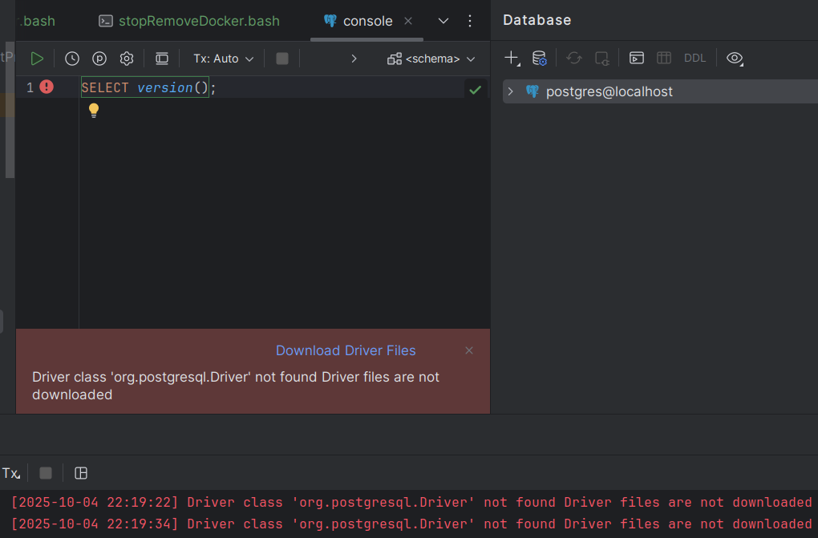
после очень длительнных попыток (помог перезапуск и чистка кеша idea) получилось вот так:
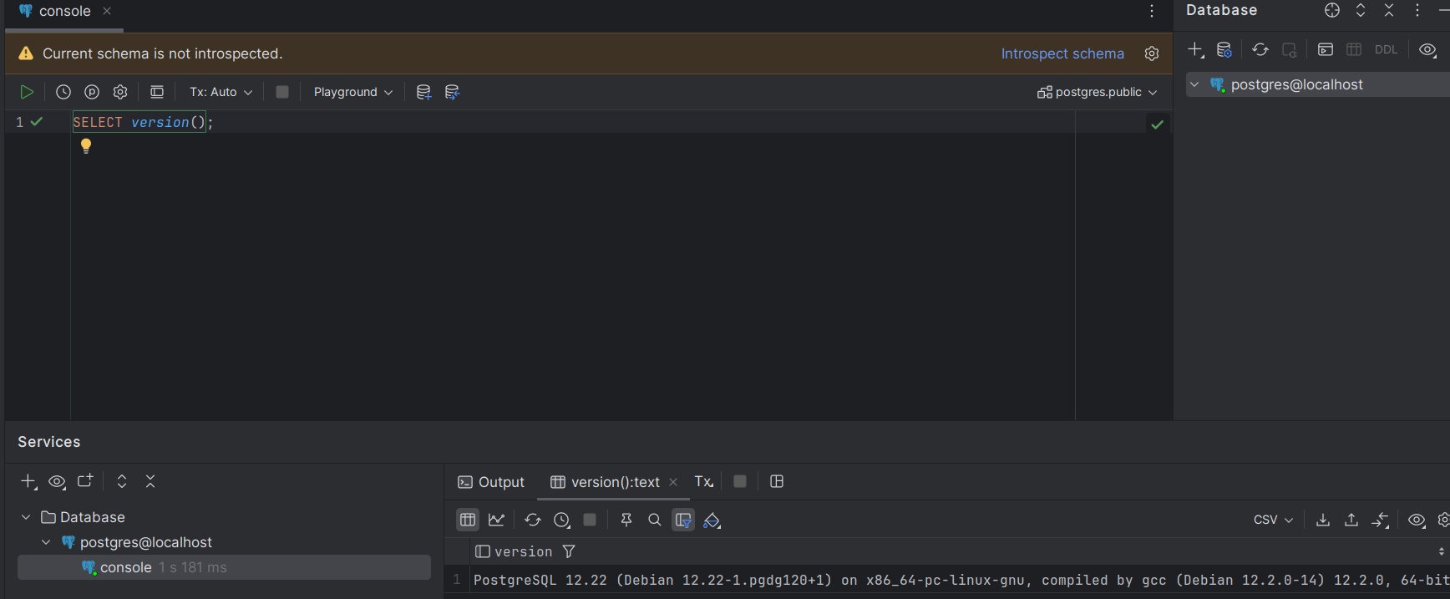
Как остановить/удалить контейнер?
Когда закончите работать:
# Остановить
docker stop my-postgres

# Удалить (если нужно)
docker rm my-postgres

